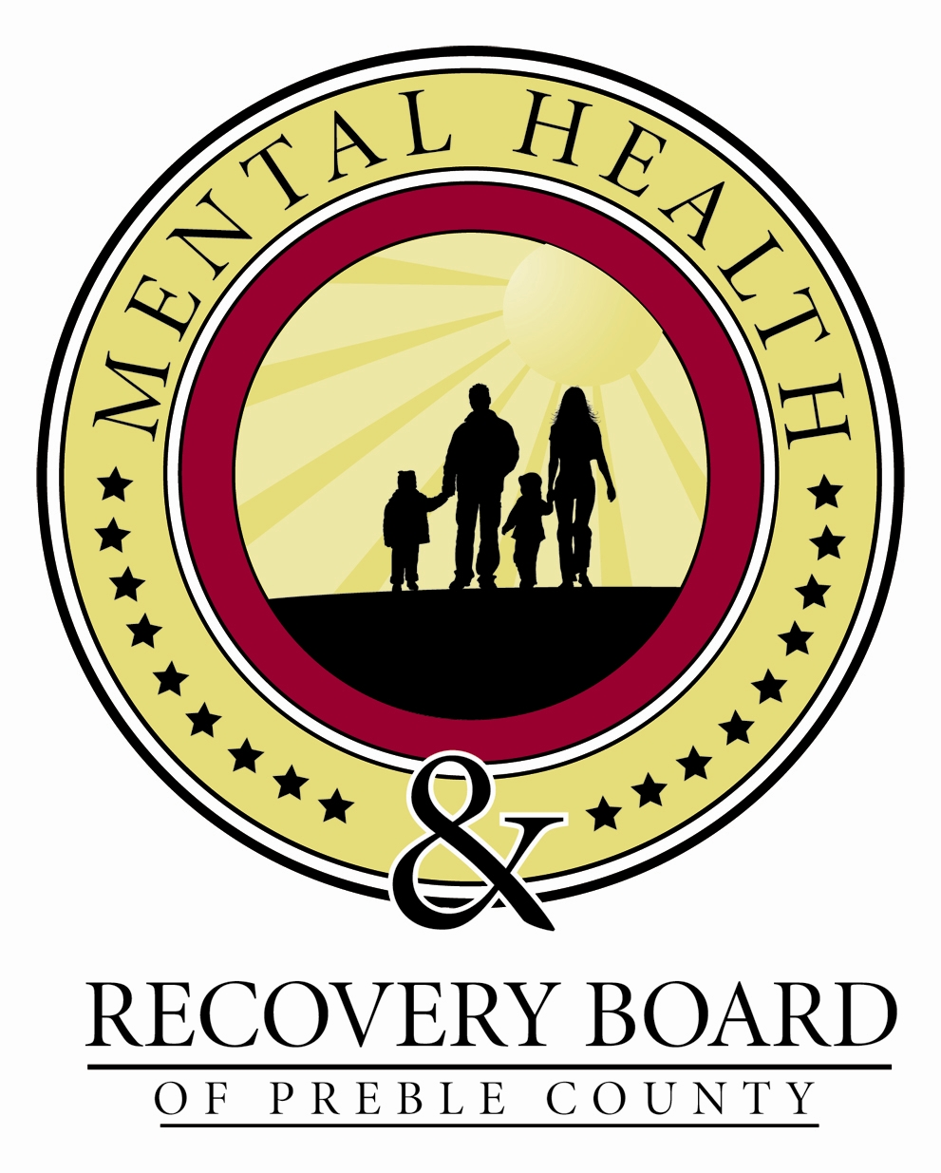
ROSC: A Report to the Community
Preble County Mental Health
& Recovery Board

Overview
•ROSC (Recovery Oriented System of Care) is a way of thinking about service delivery for those with mental
illness and/or addiction disorders that focus first and foremost on clients and family members.
•ROSC emphasizes the importance of peer supports, employment supports, housing, and transportation. It calls for services that are culturally appropriate, and delivered
in an accountable, effective, and efficient manner.
•ROSC recognizes that local management of behavioral health services is vital.
Objective: “Change the conversation”
•Mental illnesses and addiction disorders are chronic illnesses.
•Mental illnesses and addiction disorders can be successfully treated.
•Recovery is worth celebrating.

The Process

To implement a state-structured survey to assess our compliance with core ROSC principles:
Focusing on clients and families Ensuring timely access to care
Promoting healthy, safe, and drug-free communities Prioritizing accountable and outcome-driven financing Locally managing systems of care

Target groups were identified to participate in the survey:
Law enforcement/judicial
Advocates
Provider executive directors & direct service staff MHRB Board & staff
Community partners
Social Services
Public Officials
Consumers & family members

The survey was administered in two ways:
Via an online survey tool & three formal stakeholder meetings.

75 surveys returned representing:

24% from clients & family members, 20% from board staff & members, 12% from service providers, 11% from children services, 3% from criminal justice, 3% from health and 27% from “other”.

Data Analysis
During each of the community stakeholder meetings, the top 3 to 5 “gaps in services” were identified in each of the five domains. Additionally, those findings were analyzed by staff and focus groups and then prioritized to be included, as appropriate, into the MHRB three-year strategic plan.
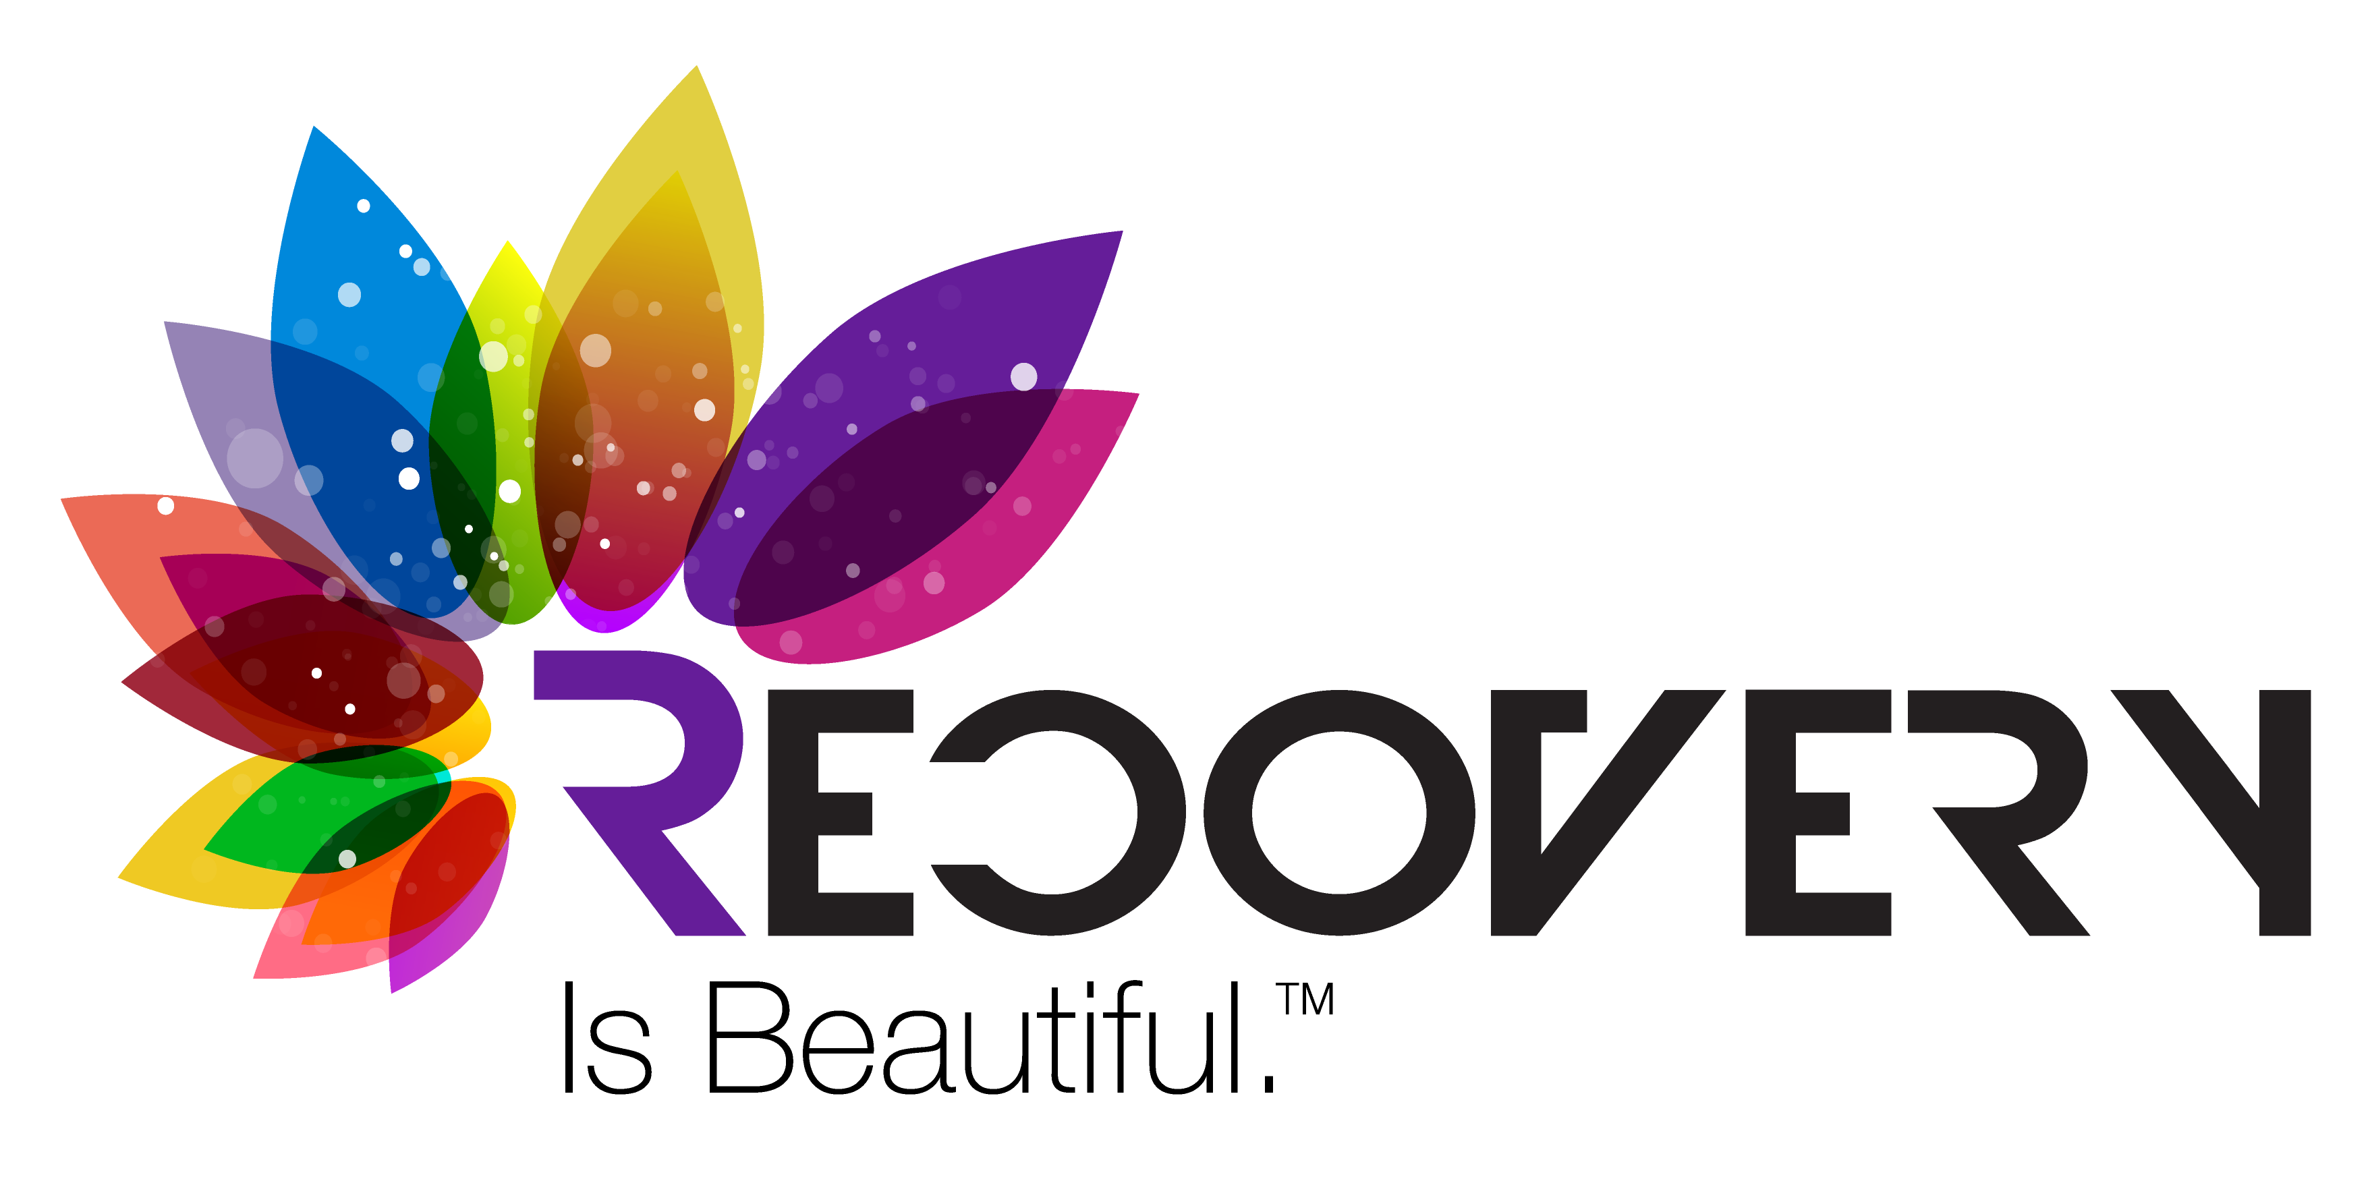
Results

Results
Strengths:
- The Board promotes and supports its agencies and clients.
- The Board, first responders, police, fire & medical community have a strong partnership addressing emerging drug trends.
- Community partnerships are strong and seen as effective. Examples include: Suicide Coalition, Substance Abuse Prevention Partnership (SAPP), School-based mental health, CIT & Trauma Informed Care.
- Generally, there is a good understanding of county agencies, their responsibilities & programming.

Opportunities for improvement:
- Barriers are not addressed for our clients and services are not provided in their natural environment. We must encourage multi-disciplinary teams and other agencies to “work together” to wholly & completely benefit the client. Sometimes, the client gets “lost” in agency politics.

- With very limited providers in our area, we are lacking in providing the residents the supports needed to recover. Clients would have a difficult time changing providers if they wished.

- We continue to battle stigma. Our city & county ordinances do not promote a sober lifestyle. There are very few “free” recreational opportunities locally. Perception is reality and we need to do a better job of developing programming in this area.

- Local residential and recovery treatment options are non-existent in our community.

Other pieces in the “recovery puzzle”
In these areas, it will be important to engage community partners to help facilitate change.
- Transportation issues across the county create challenges for consumers and families & other organizations.
- Grow opportunities for safe, sober, fulfilling activities & more opportunities to “celebrate recovery.”
- More opportunities for consumers/families to volunteer & become involved in the community.
- The system is complex with multiple agencies. Continue to improve education and communication to leverage agency resources to ensure client success.
Action Steps:
The following objectives have been included in our strategic plan 2016 – 2019.
- Implement state mandated programming, including recovery housing & residential treatment.
- Expand our current continuum of care.
- Expand services with a focus on our veterans & seniors.
- Expand peer support programming.

Bottom Line

The Preble County Mental Health & Recovery Board is accountable to consumers, families and the community. The self-assessment process helps us create a culture of care that meets the unique needs of Preble County, and the input of our partners and stakeholders helps further spur our commitment to Recovery Oriented System of Care principles.

Dec. 2015

