Thank you!  We thank our community partners, Board Members, and local Preble County residents for working alongside PCMHRB toward a common goal of creating a safe and healthy community.  Our Providers  Recovery & Wellness Center of Midwest Ohio (937) 456-7694  Next Step Living (937) 718-7436  Sojourner Recovery Services (937) 336-5414  My Neighbor's House by Thrive Therapeutics, LLC (937) 336-5052  Samaritan Behavior Health Inc. (937) 456-1915  Gebhart Counseling Solution, LLC (937)456-2805  Contact Us:  100 E Somers Street  Eaton, OH 45320  (937) 456-6827 |  |  | Preble County Mental Health & Recovery Board  Annual Report FY22

Meet the Team  The staff of PCMHRB is dedicated to advocacy for individuals and families affected by mental health and substance use conditions. They take their work seriously with their passion ignited by personal experience.  Amy Raynes  Executive Director  amy.raynes@pcmhrb.org  Sherry Hurst  Fiscal Administrator  sherry.hurst@pcmhrb.org  Autumn Cooper  Outreach Coordinator  autumn.cooper@pcmhrb.org |  |  | Board Funded Programs  PCMHRB can help fund and support the services for mental health & substance use treatments & supports listed below:  Mental Health Treatment Services:  - 24/7 Crisis Services  - School Based Treatment & Supports  - SUCCESS Liaisons  - Outpatient Treatment  - Peer Support  - Case Management  - MRSS  - Transportation Services  - Local Jail Services  - Recovery Center  - WrapAround  - Respite  - SAFE Team  - Housing  Substance Use Treatment Services:  - Jail Services  - Medicated Assisted Treatment  - Dual Diagnosis Treatment  - Residential Treatment  - TASC Services for Adults  - Recovery Housing  - Substance Use & Suicide Prevention in Schools  - Peer Support  - Outpatient Treatment  - Detox  - Recovery Center
FY22 Report Continued…  FY22 Expenditures  Direct Care 2,261,352  Admin. Planning & Oversight 271,704  Capital & Services 378,411  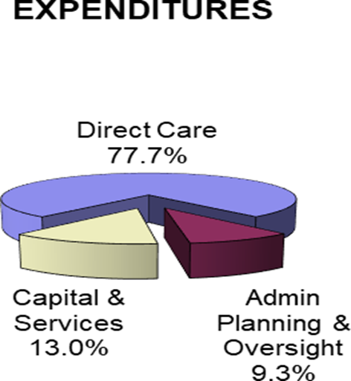 |  |  | Living Our Mission  The Preble County Mental Health and Recovery Board is statutorily responsible for planning, funding, monitoring, and evaluating substance use and mental health services in Preble County. The Board takes this responsibility very seriously to not only provide basic treatment services to our residents but to expand to provide a full continuum of care to include inpatient and residential services, peer support, harm reduction, suicide and substance use prevention, outreach and diversion, and treatment and supports to children, youth, and adults. The Board believes that mental health and recovery services and support should be accessible and affordable to all Preble County residents. The focus of every decision is our mission to ensure that quality mental health and addiction services and support are available to all Preble County residents.  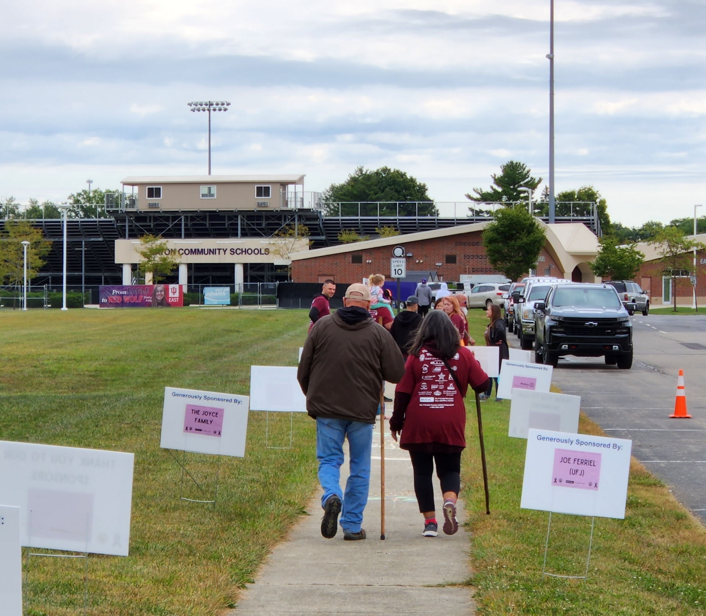
Board Members  The Board of Directors provides governance, advocacy, and expertise to move the mission forward while being good stewards of the funds that have been entrusted to them. The Board is comprised of mental health and substance use providers, faith-based and business professionals, and people with lived experience. With a clear strategic plan in place, the Board makes important decisions that impact those we serve with a knowledgeable and inclusive view.  John Allen  Robert Wood  Tyessa McQueen  Not Pictured:  Landon O’Banion  Ian Cross  Shannon Steele  David Sizemore  John Elam  Miranda Armstead |  |  | FY22 Report  FY22 Revenues  State Grant 827,300  Federal Grant 1,349,465  Local Levy 598,265  Other (Donations, Rental Income, Etc.) 159,588  