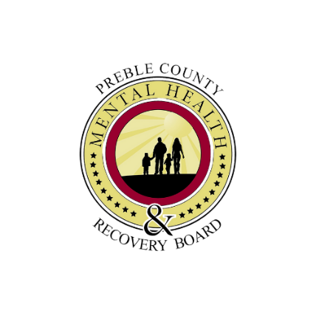

Preble County Mental Health & Recovery Board
100 E. Somers Street Eaton, OH 45320
937.456.6827

Public Records Request Form

This form is not mandatory. You are not required to make a written request or pro- vide your identity, but this form will help us fulfill your request in a timely manner.

Name Date

Address City State Zip

Phone Number Email

Please describe what records you would like to review:

How would you like to view the records?

Inspect the records in person.

Email me the records at the email address above. Mail me the records at the address above.
Make a compact disk or paper copies of the records that I may pick up.

Potential costs:
$0.10 per paper copy
Mailing costs may vary depending upon size and postal rate.

Employee Handling Request Date Fulfilled

